Advanced Excel Dashboard Design and Analysis Techniques
Week-3
Shashaank Kumar Sinha
10/7/2026

1. Introduction and Objectives
This document covers Week 3 of the Advanced Excel Reporting series: designing and building an interactive dashboard on top of the dataset cleaned in Week 2 (the 46-row, de-duplicated Hotel Booking extract). Where Week 2 made the data trustworthy, Week 3 makes it usable — turning rows and columns into a screen a manager could glance at and make a decision from.
Objectives for this task:
- Identify the key metrics and performance indicators a travel-booking manager would actually want on one screen.
- Storyboard the dashboard's layout and visual hierarchy before building anything in Excel.
- Apply advanced Excel techniques: pivot-style summary tables, dynamic charts, and conditional formatting.
- Add interactive, slicer-style filtering, and document the Excel-2007 compatibility decision this required.
- Document the full process — rationale, screenshots, and challenges — and close with a narrative on how the dashboard supports real decisions.

2. Planning: Key Metrics and Scenario
Scenario: a revenue manager for a two-property hotel group (one Resort Hotel, one City Hotel) needs a single screen that shows, for any slice of bookings, how much revenue is coming in, from where, through which channel, and at what cancellation risk — so they can decide where to spend marketing budget and which segments need a cancellation-reduction push.
From that scenario, five KPIs and four supporting breakdowns were chosen:
- Total Bookings, Total Revenue, Cancellation Rate, Average ADR, Average Lead Time — the five headline numbers (KPI row).
- Revenue by Market Segment — where the money comes from.
- Bookings by Country — which markets drive volume.
- Revenue Trend by Arrival Month — whether the season is ramping up or down.
- Cancellation Rate by Market Segment — which segment carries the most booking risk, colour-coded for instant reading.

3. Building the Data Foundation: Data and Pivot Sheets
- The Data sheet reuses the Week 2 Clean_Data output unchanged, with two helper columns added: Arrival_Month (text month-year, used to group the trend chart) and FilterMatch, a 1/0 flag computed per row from the dashboard's two filter cells.
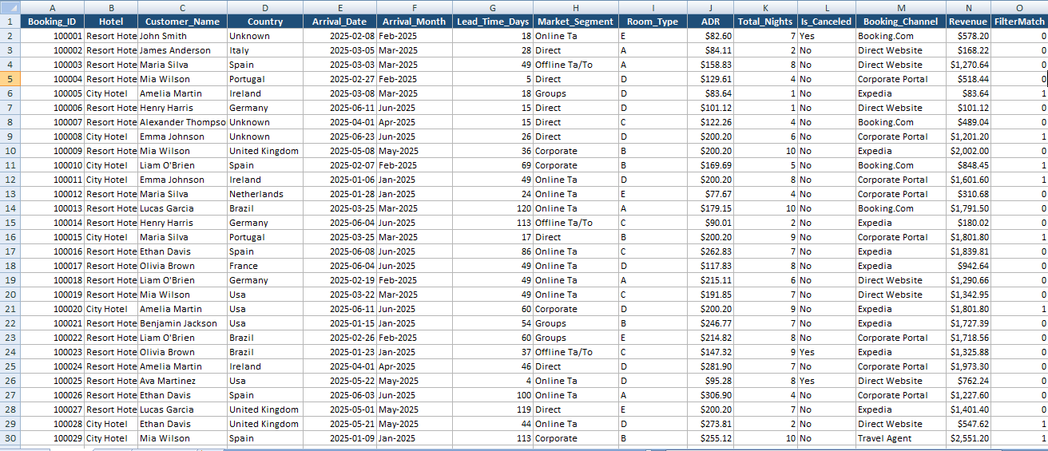

Figure 1 — Data sheet: the Week 2 clean dataset plus Arrival_Month and FilterMatch helper columns

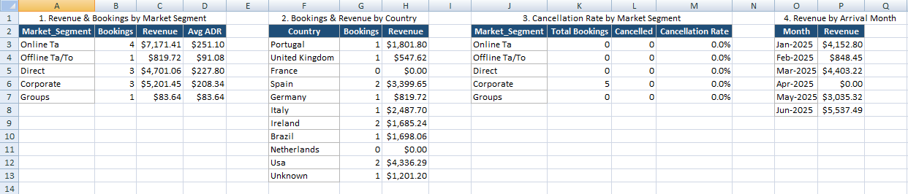
Figure 2 — Pivot sheet: four cross-tab tables each driven by SUMPRODUCT formulas referencing the Data sheet's FilterMatch column

4. Interactivity: Slicers in Excel 2007
Native Excel Slicers — the clickable filter buttons most people associate with an interactive PivotTable dashboard — were introduced in Excel 2010 and do not exist in Excel 2007. Since this series has used Excel 2007 throughout, building the dashboard around real Slicers would have produced a file that does not work in the target version.
The functional equivalent used here is a pair of Data Validation dropdown cells (Hotel and Cancelled?) on the Dashboard sheet. Each one is an ordinary cell with a dropdown list attached (Data tab → Data Validation → List), and every SUMPRODUCT formula in Pivot and every KPI formula reads those two cells as its filter criteria. The user experience is nearly identical to a Slicer — click, choose a value, watch the whole sheet update — the only difference is a dropdown arrow instead of a floating button.

5. The Dashboard: KPIs, Charts, and Conditional Formatting
The finished Dashboard sheet matches the storyboard: title and filters at top, five KPI cards, then a 2×2 grid of charts, then the colour-scaled cancellation table — all on one screen, with no scrolling needed.
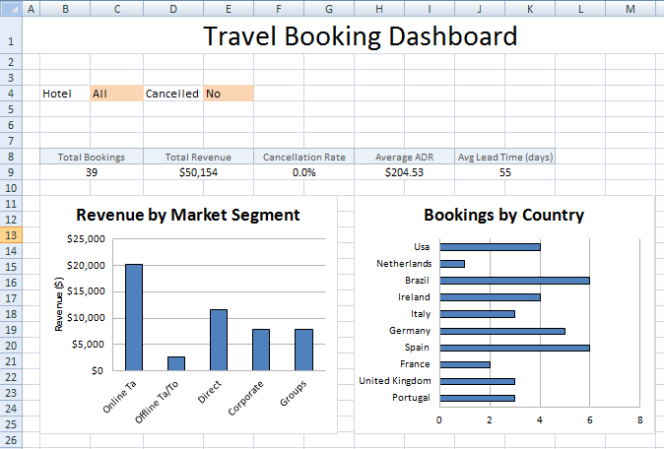
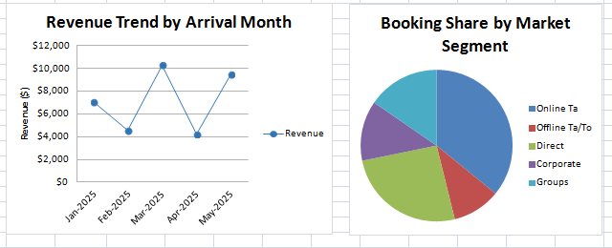
Figur3 — Full Dashboard sheet with both filters set to “All”: 46 bookings, $54,369 total revenue, 15.2% cancellation rate, four charts, and the colour-scaled cancellation table at the bottom. Offline TA/TO stands out immediately at 42.9% cancellation risk versus 0.0% for Corporate.
Chart choices and the question each answers:
- Revenue by Market Segment (column chart) — which segment should marketing budget favour? Online TA dominates at roughly $21.5k.
- Bookings by Country (horizontal bar) — which markets drive volume? Brazil and Spain lead at 7 bookings each.
- Revenue Trend by Arrival Month (line chart) — is the season ramping up? Revenue climbs sharply from April into June.
- Booking Share by Market Segment (pie chart) — what's the overall mix, at a glance, for a one-second read.
The colour scale on the cancellation table (bottom of Figure 4) is the dashboard's one piece of pure conditional formatting, as distinct from the formula-driven KPI values: it needs no legend because green-to-red is read instantly as low-risk-to-high-risk, which is exactly why it was chosen for a risk metric rather than for a neutral one like booking count.
Metric | All Data | Filtered: City Hotel, Not Cancelled
Total Bookings | 46 | 12
Total Revenue | $54,369 | $17,977
Cancellation Rate | 15.2% | 0.0% (by definition of the filter)
Average ADR | $191.96 | $207.29
Average Lead Time | 53.8 days | 53.8 days (also filter-driven — 53.75 rounds the same as 53.78, a coincidence)

8. Challenges Encountered and How They Were Resolved
- Native Slicers are unavailable in Excel 2007 — resolved with Data Validation dropdowns driving SUMPRODUCT formulas (Section 5), which gives equivalent click-and-filter behaviour without the version dependency.
- A line chart series initially rendered invisible (white line on white fill, inherited from a default chart style) — resolved by explicitly setting the series line and marker colour instead of relying on a built-in chart style.
- Cancellation Rate needed to ignore the Cancelled? filter (filtering to “Cancelled = Yes” would trivially show a 100% rate for every segment) — resolved by having the Cancellation Rate table's formulas read the Hotel filter only, which is noted directly in that table's own heading so the exception is never ambiguous to a reader.
- Keeping every chart and KPI pointed at one pivot layer (Pivot_Summary) rather than at Data directly, so that a single filter change propagates everywhere — this was a deliberate upfront architecture decision rather than a problem fixed after the fact, but it is the single choice that made Section 7's test possible in two cell edits instead of dozens.

9. Using the Dashboard for Business Decisions
With both filters on “All,” the dashboard already surfaces three decisions a revenue manager could act on immediately:
- Online TA generates the most revenue ($21.5k) but Offline TA/TO has by far the worst cancellation rate (42.9%, versus 9–14% for every other segment) — that combination says the booking-confirmation process for offline travel agents deserves review before more volume is pushed through that channel.
- Brazil and Spain are the two largest source markets by booking count, which argues for keeping marketing spend concentrated there rather than spreading it thin across ten countries with only 1–5 bookings each.
- Revenue climbs steadily from an April dip into a strong June — useful for staffing and inventory planning, since it signals the property should be gearing up for a summer peak rather than treating demand as flat.
The filters turn this from a static report into a working tool: switching Hotel to City Hotel isolates exactly how much of the Offline TA/TO cancellation problem belongs to each property (useful if only one hotel's partner-agent relationships need renegotiating), and switching Cancelled? to No shows what the revenue base looks like once cancellation risk is excluded — the $17,977 figure in Section 7 is the confirmed, bookable revenue a manager could actually plan against, as opposed to the $54,369 headline total which still includes bookings that may not convert.

10. Conclusion
The dashboard demonstrates that interactive, filterable reporting does not require features exclusive to newer Excel versions: SUMPRODUCT, Data Validation, Conditional Formatting, and native charts — all available in Excel 2007 — reproduce the experience of a PivotTable-and-Slicer dashboard almost exactly, provided every visual is built against one disciplined pivot layer rather than scattered across the raw data. That same Pivot_Summary architecture is also what makes the workbook easy to hand off: a future analyst with Excel 2010+ can bolt on real Slicers in minutes (Section 5) without re-architecting anything underneath.

Appendix: Companion Workbook Contents
- Data — The Week 2 clean dataset plus Arrival_Month and FilterMatch helper columns (Figure 1).
- Pivot— four SUMPRODUCT-driven cross-tab tables feeding every chart and KPI (Figure 2).
- Dashboard — filters, KPI cards, four charts, and the colour-scaled cancellation table (Figures 3).

